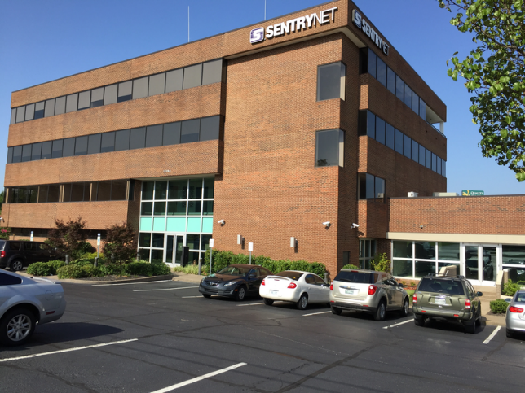
FACT SHEET:

1341 Sycamore View Road
Memphis, TN 38134
Property built: 1983.
Size: 38,500, 4 story
Lot: 1.5599-acre parcel
Roof: Membrane roof installed August 27, 2011, 20-year warranty from Soprema.
Elevator: two hydraulic elevators, installed and serviced by Otis Elevators in October 1995, $609.44/month for current owner.
HVAC: OSB cloud hosts the HVAC system, $300 monthly, month-to-month contract.
Fire Suppression: Nichols Fire services and monitors the fire alarm system, $400/month, month-to-month contract.
Pest Control: Mack Pest Control, $140/month, month-to-month contract.
Location: Southwest intersection of Macon Cove and Sycamore View Road, just east of the intersection of I-40 and Sycamore View Road.
Parking: Fenced parking lot with over one hundred parking spaces at both front and rear of premises. Ingress from Sycamore View and Macon Cove. Fence installed February 2024. Exterior lighting upgraded to LED in 2023.
Zoning: EMP

Cathy Anderson, CCIM
Office: (901) 758-5670
Cell: (901) 282-6312
cathy.anderson@crye-leike.com

Data Certification Information:

1341 Sycamore View Road, Memphis, TN, 38134, is known as a SOC II (Security Operation Center) certified property. Property is certified by Underwriter’s Laboratories and undergoes annual testing for SOC II compliance.

Included in the sale of this property:
- Primary and secondary A/C units, less than three years old
- UPS (Uninterrupted Power Supply)
- Primary and back-up generators

UPS system allows for remote access. Unit sends notifications for any low batteries. Every battery has a separate back-up battery. Two-hour fire walls installed around data center with SOC II ventilation.

Facility meets all requirements for UL 827 facility.



Cathy Anderson, CCIM
Office: (901) 758-5670
Cell: (901) 282-6312
cathy.anderson@crye-leike.com

